App in a Day

Hands-on Lab Step-by-Step

December 2019

Contents

Importing Module 1 Completed 1

Task 1: Create a new environment 1

Task 2: Import application 3

# Importing Module 1 Completed

Follow the steps below, if you did not complete Module 1 and would like to skip to Module 2

## Task 1: Create a new environment

1. Open a new browser tab, navigate to <https://admin.powerapps.com> select **Environments** and click **New Environment**.

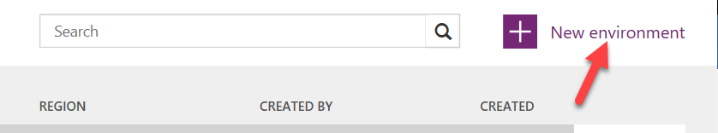

1. Provide an **Environment Name**, select **Region**, select **Environment Type**, and click **Create Environment**.

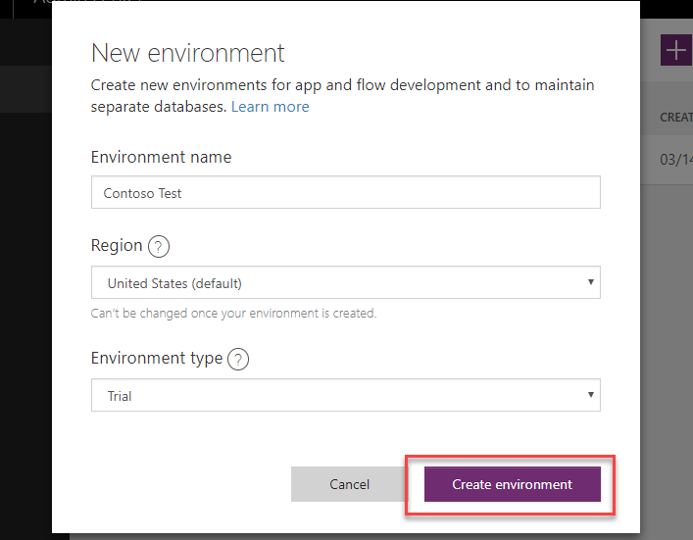

1. Click **Create Database**.

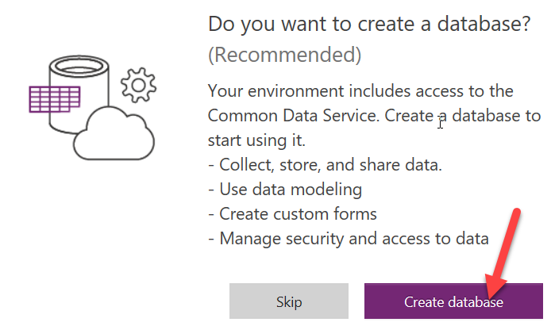

1. Select **Currency** and **Language**, and then click **Create Database**.

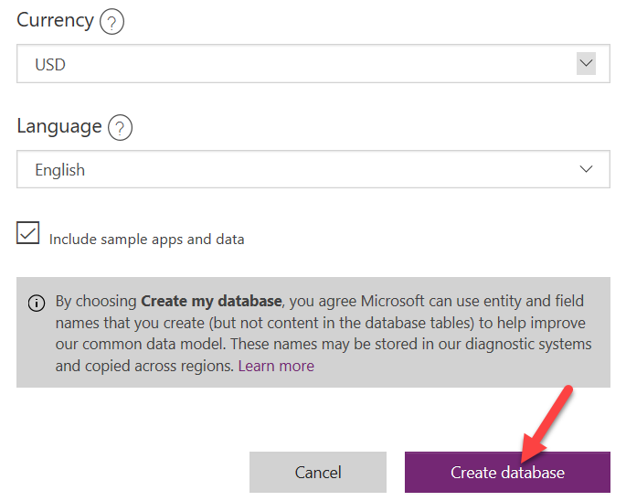

1. Open the new environment.

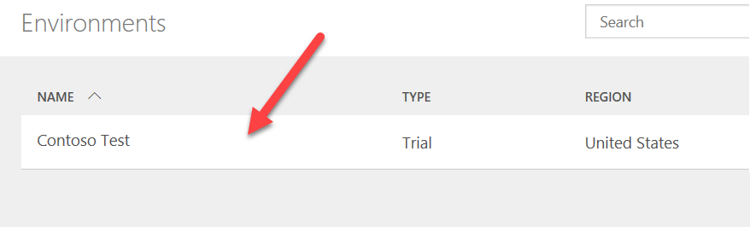

1. Wait for the database to be created

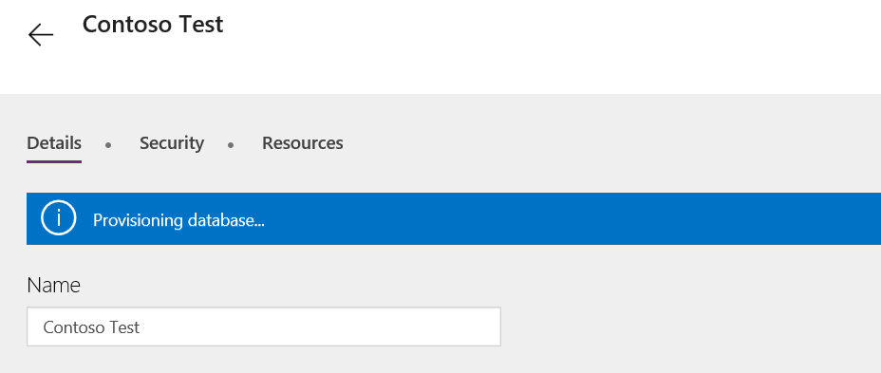

## Task 2: Import application

In this task, you will import the completed Module 1 application.

1. Open a new browser tab, navigate to <https://make.powerapps.com>
2. Click on the environment name and select the environment you created in task 1.



1. Select **Apps** and click **Import Package**.

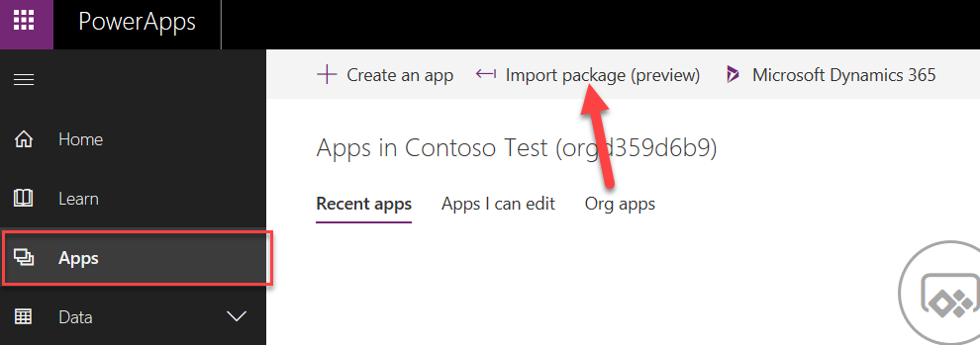

1. Click **Upload**.

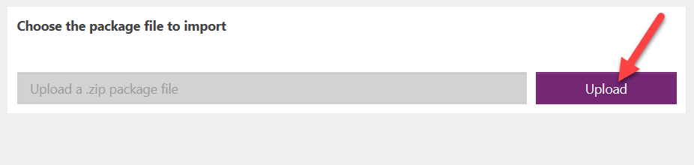

1. Select the zip file located in Module 1 completed folder and click **Open**.

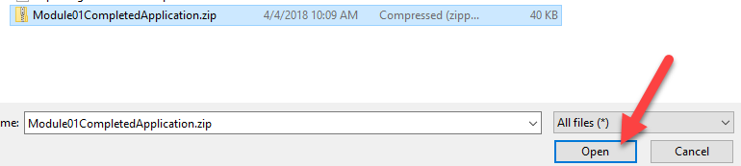

1. Click **Import**.

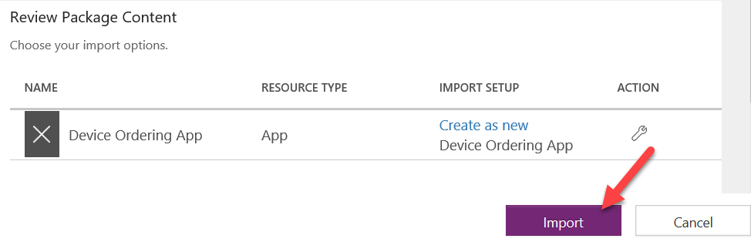

Wait for the application import to complete.

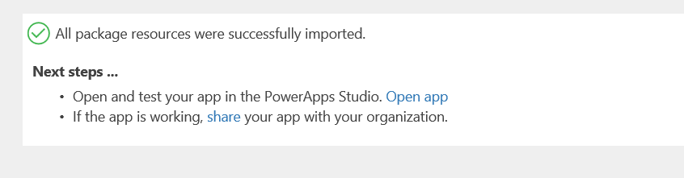

1. Click **Apps**, locate the application you imported, click … and click Play.

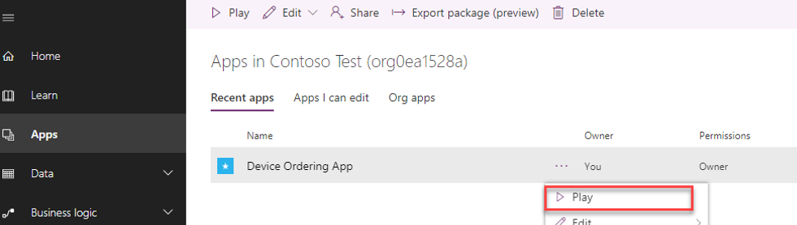

1. Confirm the application loads.

